
Links you should know

Basics
CAcert Root-Certificate http://www.cacert.org/certs/root.crt
CAP form https://secure.cacert.org/cap.php

Policies und Handbooks
Essential Policy-Documents http://www.cacert.org/policy
http://svn.cacert.org/CAcert/Policies/
Assurance Handbook http://wiki.cacert.org/AssuranceHandbook2
PoJAM http://wiki.cacert.org/PoJAM

Names
Practice on Names http://wiki.cacert.org/PracticeOnNames
Netherlands Roepnams http://www.meertens.knaw.nl/voornamen/vnb/

ID documents
CAcert Acceptable Documents http://wiki.cacert.org/AcceptableDocuments
PRADO (European Documents) http://www.consilium.europa.eu/prado

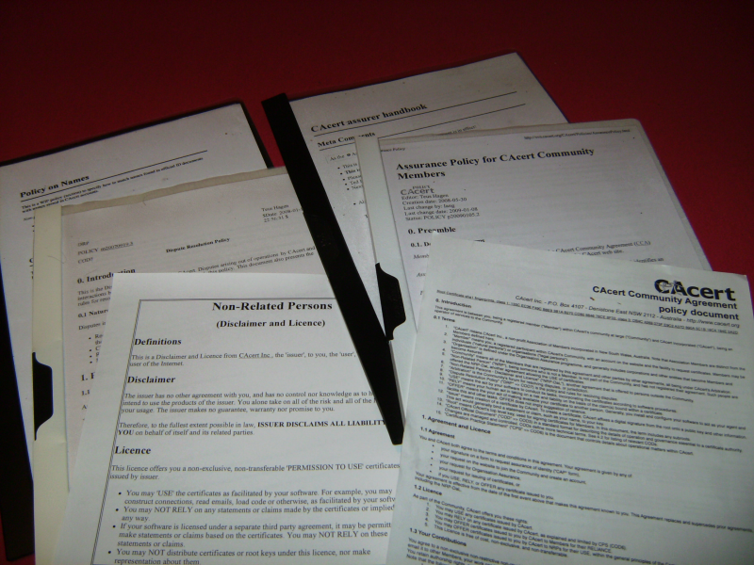
Policies

Rules for members CAcert Community Agreement
Policy for Assurances Assurance Policy
Dispute Resolution Policy, Arbitration Dispute Resolution Policy
License for Non-Related-Members Root Distribution License
Privacy Policy Privacy Policy
Security Policy for Administrators Security Policy
TTP Assisted Assurance program TTP Assisted Assurance Policy
Junior Assurers and Members Policy on Junior Assurers and Members


Purpose of Assurance (AP 1.1, Assurance Statement)

Member |  | Is a bonafide member
Account |  | A member has an Account.
Certificates |  | With an Account member can create certificates
Arbitration |  | Certificates can be mapped to an account by their serial numbers, therefor member can brought into Arbitration
Data | 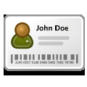 | Some data is known about the user
Name-Rules

5 Strict Rules

Relaxed Rules
- NL Tussenvoegsels
- NL Common Short Givennames → Database: http://www.meertens.knaw.nl/voornamen/vnb/
- digraphs: NL ij ↔ y UK: ph ↔ f
- more: see PracticeOnNames

- Check for Strict Rules
- Check for Relaxed Rules

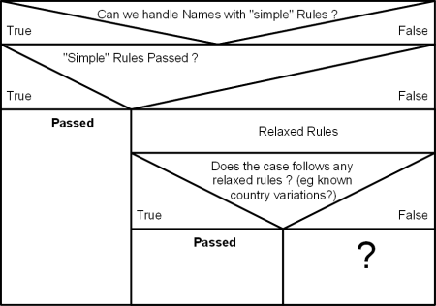

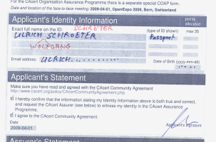
CAP-Forms (AP 4.5)

„The magnificent 7“

- Assuree's Part (Applicant)
- Names as in ID doc, see. Names-Rules
- Date of Birth a.) D->D, M->M, Y->Y b.) 01 → 10 c.) 09 → Sep
- Primary Email Ask for account and primary Email
- CCA Acceptance Attention on "old" CAP forms
(PoJAM: parental consent exists)
- Request for Assurance Privacy purpose
- Date of Assurance
- Signature Optional check against newer documents
- Assurer's Part
- Name of Assurer
- Assurance Points
- Assurance-Statement
- Date
- Location of Assurance
- Signature

- Accepted documents Optional - Essential for Evidence Gathering

CAcert Community Agreement (R/L/O)


Agreement of the members


Riscs : You may find yourself subject into Arbitration

Liabilities : Liabilities limited to 1000 Euro

Obligations : Keep your Email Address in a good working order
(→ Check Account exists, primary Email Adress)

File a Dispute

- E-Mail to support@cacert.org
- Data of the member (Name, primary Email)
- Acceptance to CCA and DRP
CARS
- CARS (CAcert Assurer Reliable Statement)

Notes

